MSKW TRIAL RESULTS

Teresa Ward - After successful cross examination by Ms. Ward at trial, the WCJ ordered that Applicant, employed by a major airline, TAKE NOTHING re: specific alleged injury to multiple body parts including internal, neurological, weight loss and ENT.
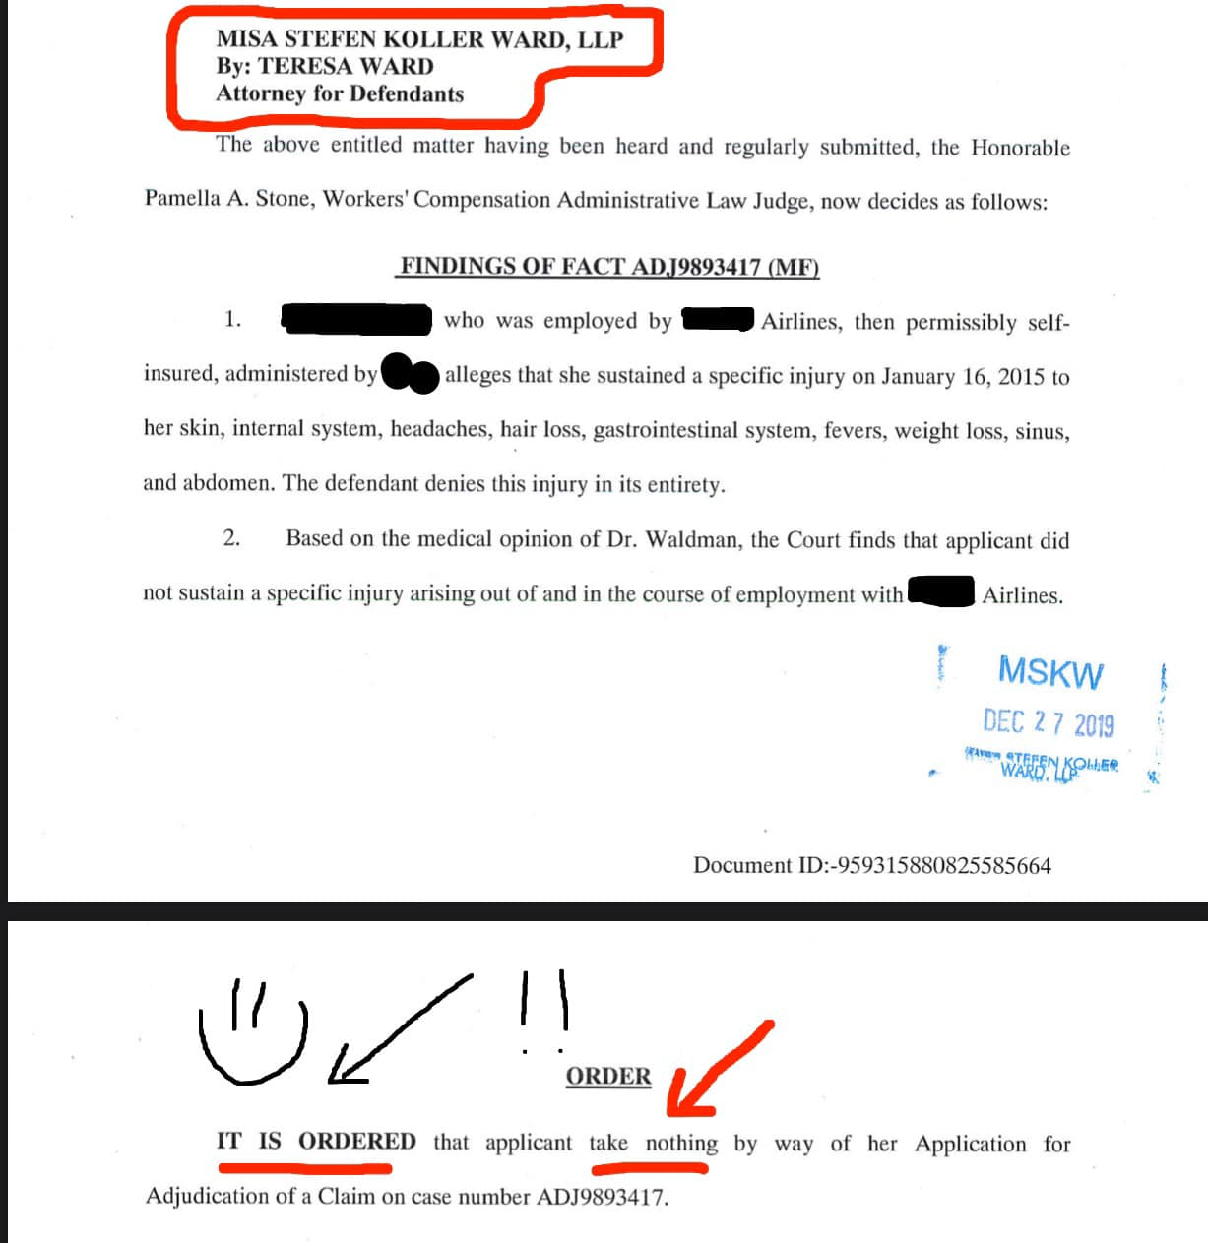

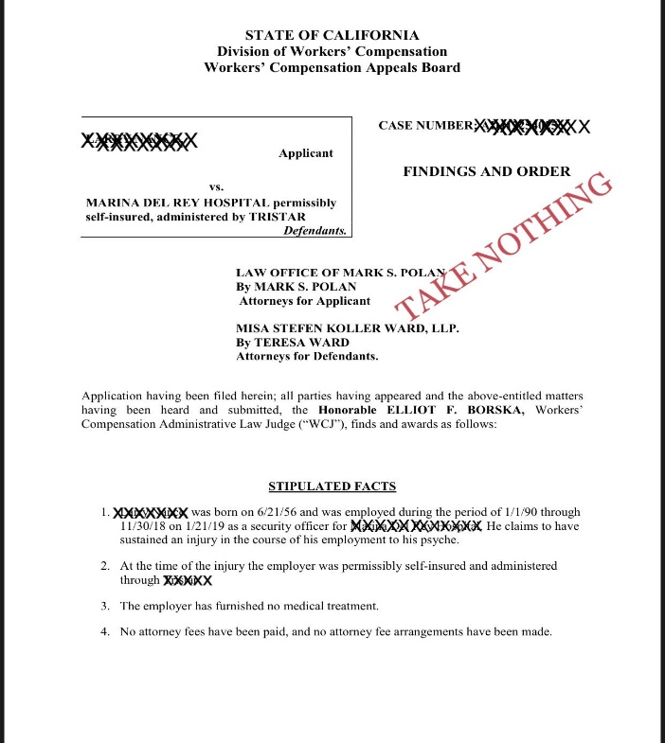
Teresa Ward – After aggressively litigating this case and proceeding to trial with employer witnesses, Judge Borska found the defense witnesses to be more credible and awarded the defendant a Take Nothing.

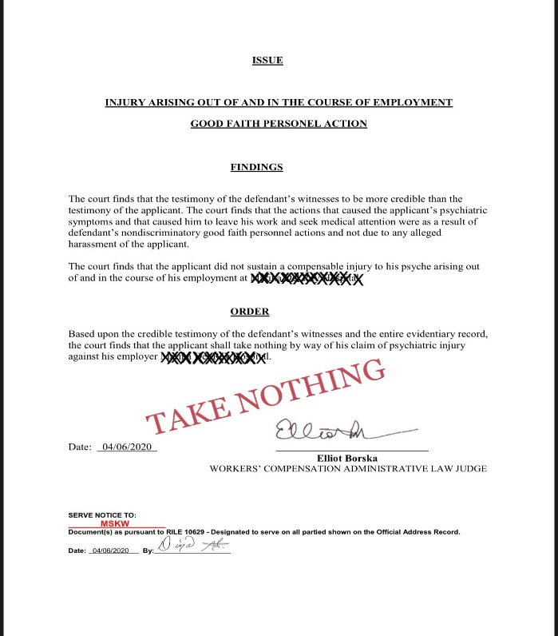

Pegah Taghdiri - Pegah was able to successfully litigate against entitlement to over one year (and continuing) of TTD benefits asserted by Applicant at Trial, saving our dedicated client over $25,500 of potential retroactive and continuing TTD exposure. After hearing witness testimony and review of the record at Trial the WCJ DENIED Applicant’s request for additional periods of temporary disability (over 1 year and continuing).

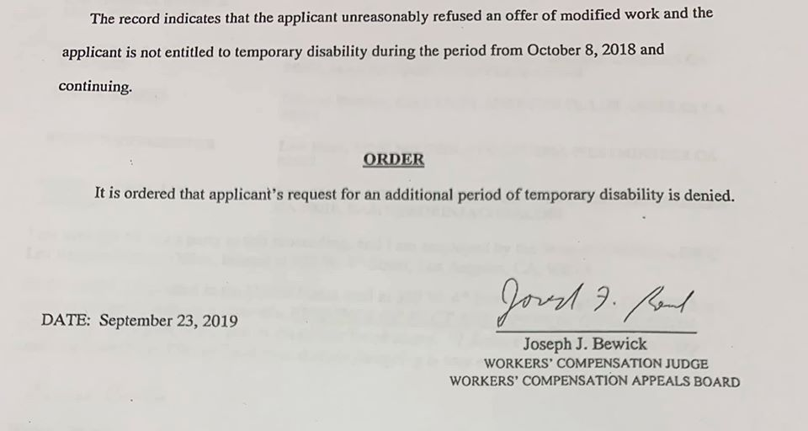

Pegah Taghdiri - In this case, Applicant attempted to circumvent the 6-month psych rule, arguing “unusual and extraordinary” circumstance. Although Applicant obtained a compensable psychiatric report, after cross examination during trial, the WCAB trial judge found that the report failed to reach the threshold of substantial evidence.
Applicant also filed alleged injuries to orthopedic, respiratory, cardiovascular and internal body parts.
Pegah was able to aggressively close discovery despite the plethora of allegations filed by Applicant, successfully convincing the MSC judge that Applicant was not entitled to additional orthopedic and/or internal medical legal evaluations as Applicant failed to comply with LC 4060/4062.2 process.
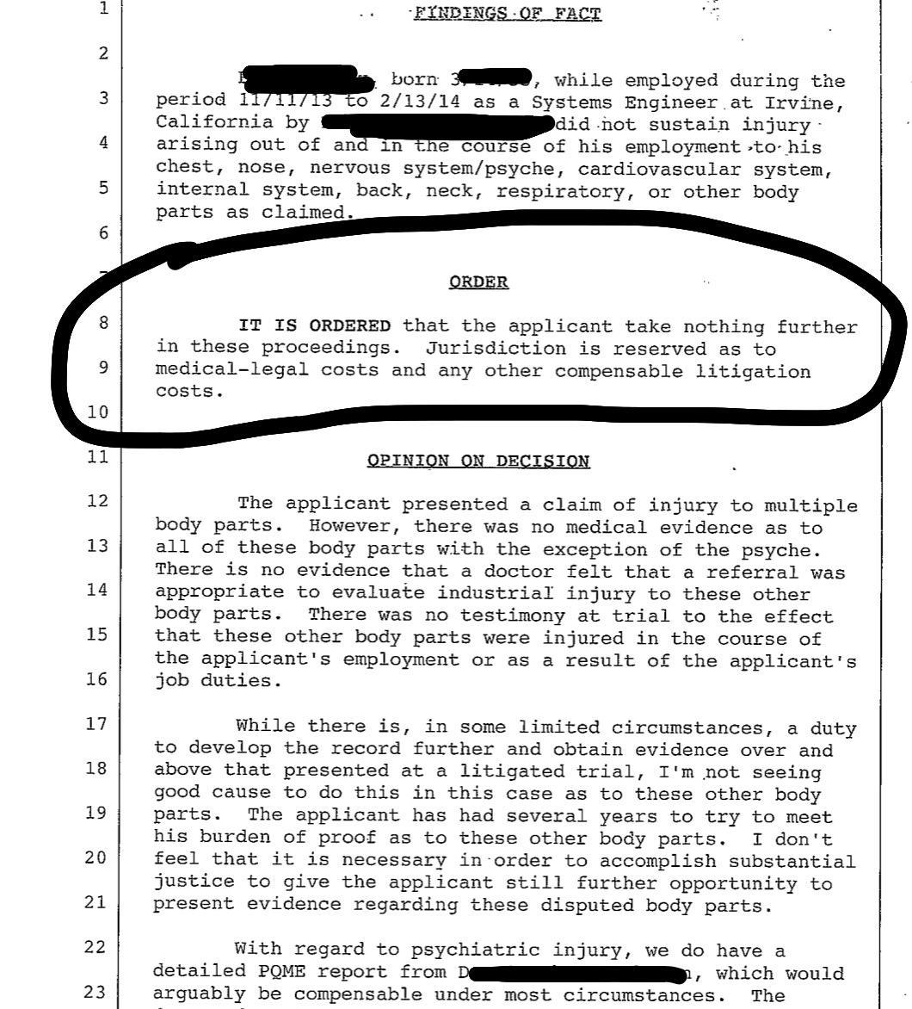

Martin W. Stefen – Martin took this case to trial on AOE/COE for an alleged continuous trauma and obtained a Take Nothing as the applicant failed to meet the burden of proof to substantiate his claim.
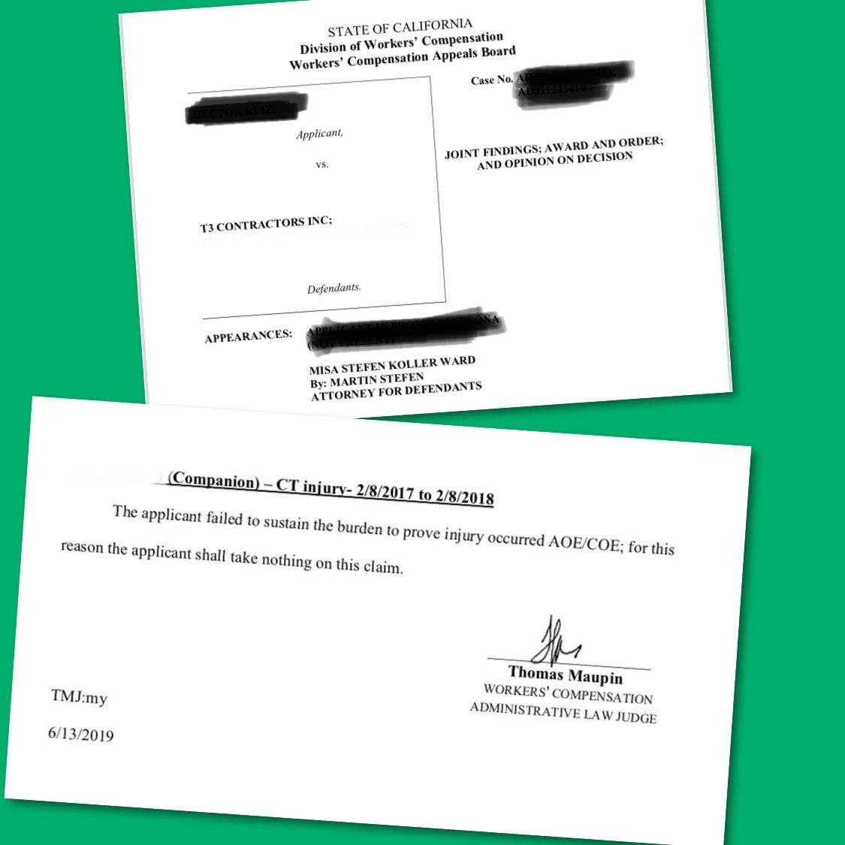

Michael Misa - Awesome result on the verge of trial. It is important to understand your leverage and negotiation power, and to try not and settle for more than a case is worth.... or... just go to trial. $500 settlement. $75 attorney fees.

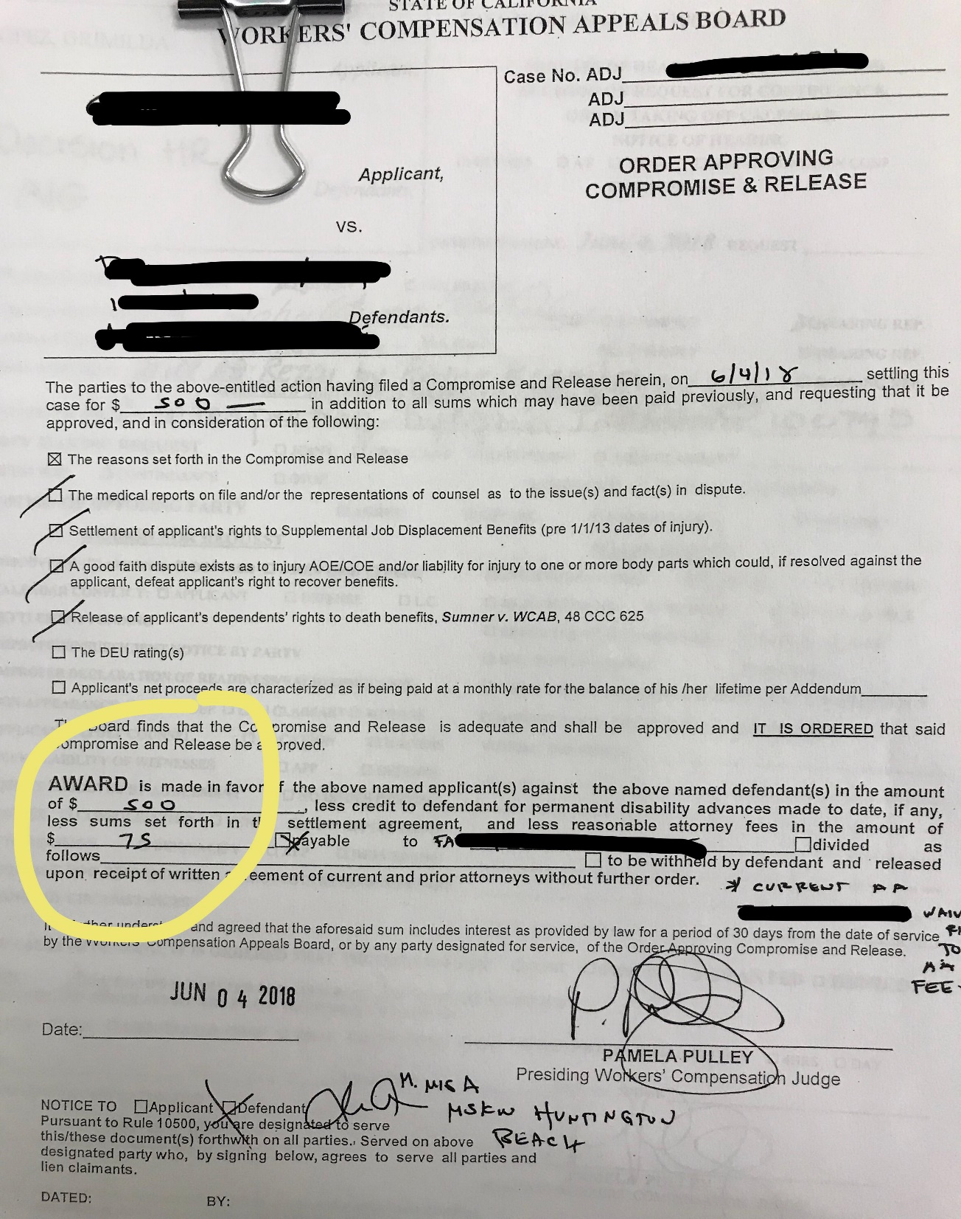
Matt Koller – Matt was able to successfully remove a decision provided by the WCAB. When MSKW received this file, Co Defendant already obtained a PQME report which pinned all liability against our client. Mr. Koller aggressively took the challenge to combat same pursuant to LC 5412. Mr. Koller cross examined the Co Defendant's PQME and immediately requested our own panel QME pursuant to LC 4062.2. The conference Judge ordered that our dedicated client was bound by Co Defendant's PQME report in part, because we participated in a cross examination in attempts to combat a potential 100% finding against our client. MSKW argued that we have a due process right to obtain our own panel as our client did not have the due process right to participate in the medical legal process pursuant to LC 4062.2. The conference Judge's decision was RESCINDED. Our dedicated client has the entitlement to obtain their own medical legal evaluation.
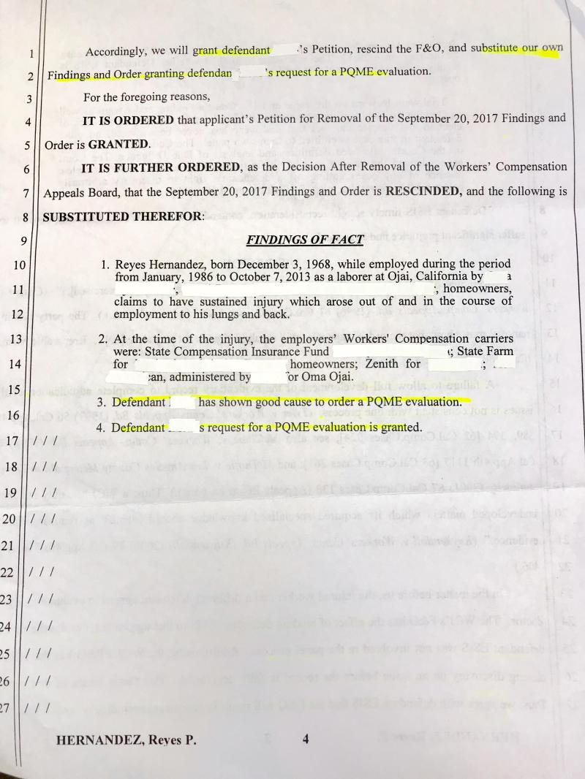

Adam Lee - Adam aggressively argued that a medical lien was not timely filed and thus barred by statute of limitations pursuant to Labor Code 4903.5, saving our dedicated client $29,334.72 in medical expenses. Adam obtained a Take Nothing.
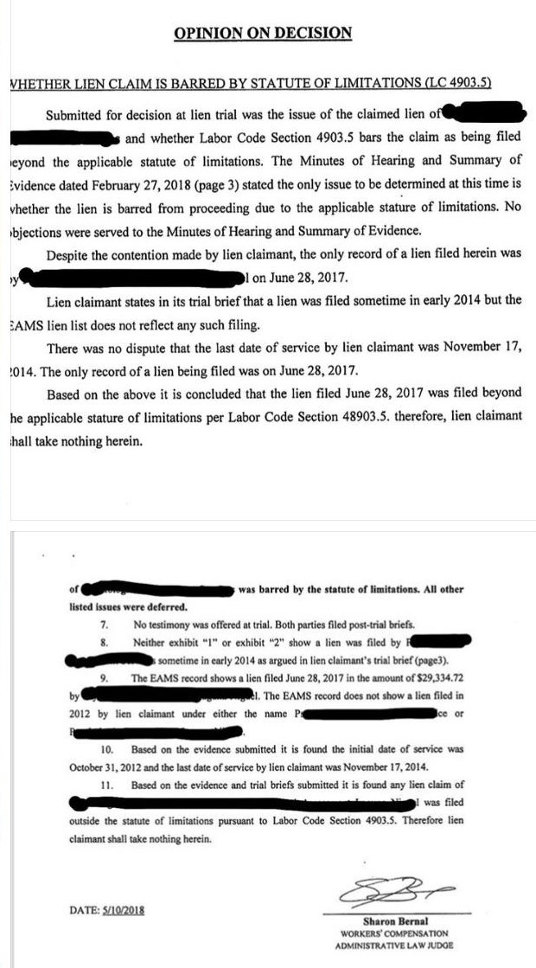

Ryan Kayrell – Matter taken to trial on AOE/COE for a continuous trauma from July 15, 2018 to October 17, 2018 for the nervous system, psyche, stress, and back. Based on the medical reporting and applicant’s failure to meet the burden of proof to establish injury AOE/COE, Ryan obtained a Take Nothing on January 27, 2021, for our client!

 | Case No.
Applicant,
 | JOINT
vs. | FINDINGS AND ORDER
Defendants.
The above entitled matter having been heard and regularly submitted, the Honorable Charles Bentley, Workers' Compensation Administrative Law Judge, now decides as follows:

FINDINGS OF FACT ADJ11638541
1. APPLICANT born on while employed on 08-21-2018 as a highway crew at Bakersfield , California, by, whose workers’ compensation insurance carrier was, sustained injury arising out of and occurring in the course of employment to his 340 left second FINGER.
2. There were no periods of Temporary or Permanent disability as a result of the injury.
3. Applicant WILL NOT require further medical treatment to cure or relieve from the effects of this injury.
4. There are no funds from which to award attorney fees.

ORDER:
IT IS ORDERED that applicant takes nothing further on this claim.

FINDINGS OF FACT
- Applicant failed to sustain his burden of proving he sustained industrial injury to his Nervous system, stress, psyche, and back, arising out of and in the course of his employment with defendant during the period July 15, 2018 through October 17, 2018.

ORDER:

The conditions of compensation pursuant to Labor Code Section 3600 having been shown not to have been met, IT IS ORDERED that applicant takes nothing on this claim.

DATE:_____January 27, 2021_________ _________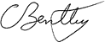_________
Charles Bentley
workers' compensation
administrative law judge

Service by mail on interested parties shown on the Official Address Record
Date: 1/27/2021 by;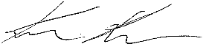
Keith Ruiz

OPINION ON DECISION
; Date of Injury: CT July 15, 2018 to October 17, 2018

INJURY ARISING OUT OF AND IN THE COURSE OF EMPLOYMENT:

Based upon Applicant’s testimony, and the medical report of Ardalan Nourian, M.D., dated January 17, 2020, it is found that Applicant did not sustain industrial injury to his Nervous System, Stress, Psyche and back arising out of and occurring in the course of employment during the period July 15, 2018 through October 17, 2018.

It is further found that the medical reporting of Ardalan Nourian, M.D., dated January 17, 2020, is substantial evidence. The Applicant testified that the doctor only spent 2-3 minutes with the patient and that the doctor refused to examine the applicants back. However, on page two of the report that doctor indicates that he spent one hour of face to face time with the applicant. Further, the doctor did evaluate the applicants back as outlined on page 14 of the report. The doctor also reviewed 51 items in rendering his opinion that the applicant did not sustain a cumulative trauma injury. Consequently, the report of Ardalan Nourian, M.D., dated January 17, 2020 is found to be credible, and substantial medical evidence which was not rebutted by the applicant.

OTHER ISSUES:

All other issues are rendered moot by the finding that there was no injury arising out of and occurring in the course of employment. All liens not awarded as medical-legal are denied. There are no funds from which to award an attorney’s fee.
DATE:_____January 27, 2021_________ __________________
Charles Bentley
workers' compensation
administrative law judge

